Midterm project
Muhummad Nafeel

Brand name: Thread & Thorn
Brand logo:
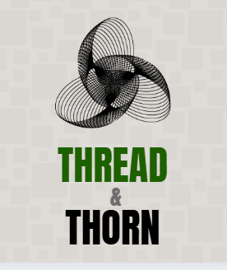

Social media handles:
Facebook page link : https://www.facebook.com/profile.php?id=61579583807779&sk=about

2. Marketing Campaign Plan
- Campaign Title: “Tradition in Every Thread”
- Objectives:
  - Reconnect with loyal customers through nostalgia.
  - Attract Gen Z & Millennials with trendy digital content.
  - Build strong online presence & engagement.
- Target Audience:
  - Demographics: Females 16–40 years, Pakistan & abroad.
  - Psychographics: Fashion-conscious, culturally attached, values tradition, follows online trends.
- Campaign Schedule (1 Month):
  - Week 1: Teaser posts + launch announcement.
  - Week 2: Product showcase reels & influencer collabs.
  - Week 3: Customer testimonials + giveaways.
  - Week 4: Sale announcement + final hype.
- Budget Breakdown (PKR 500,000):
  - Social Media Ads: 60% (PKR 300,000)
  - Influencers/Brand Ambassadors: 20% (PKR 100,000)
  - Content Creation (photography, Canva posts, videos): 15% (PKR 75,000)
  - Contingency/Other: 5% (PKR 25,000)
- Per Post Budget (10 posts): PKR 30,000 each (ad spend + design)

CAMPAIGN CONTENT
5 SAMPLE CANVA POSTS
- TEASER: A LEGACY IS RETURNING!

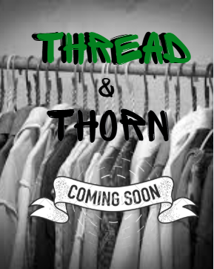

2.LAUNCH POST: WHERE HERITAGE MEETS ELEGANCE !

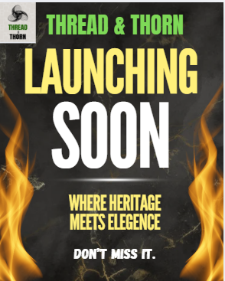

PRODUCT SHOWCASE POST:
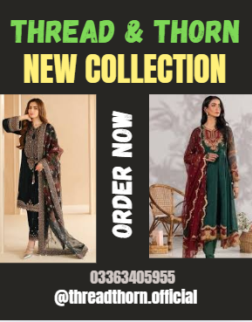

CUSTOMER ENGAGEMENT POST:
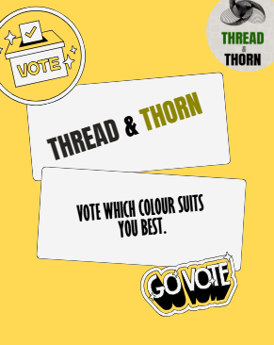

SALE OR GIVEAWAY POST:
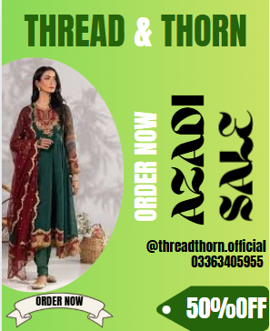

MOCK RESULTS PER POST :
Mock Post Performance Results
Post Type | Caption/Theme | Reach | Engagement | Clicks | Estimated Cost (PKR)
Teaser Post | “A legacy is returning… Are you ready?” | 25,000 | 3,200 | 500 | 30,000
Launch Announcement | “Where Heritage Meets Elegance” | 35,000 | 4,800 | 750 | 30,000
Product Showcase Post | Post of model in ethnic wear | 40,000 | 6,500 | 1,000 | 35,000
Customer Poll | “Which color suits you best?” | 30,000 | 5,200 | 600 | 25,000
Giveaway Post | “Win a free outfit! Like, Share & Tag ” | 50,000 | 8,000 | 1,300 | 35,000

